Task 2 :

1 Create user with name Techie and provide sudo access to user.?

1 step : type a command sudo adduser and user Name
For Example : sudo adduser mother
2 after that give you are current user password
3 after giving password
4 You can update you are New password for the user mother
5 Type ENTER for all new values
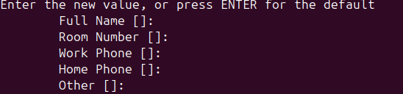

6 and enter y correct informtion
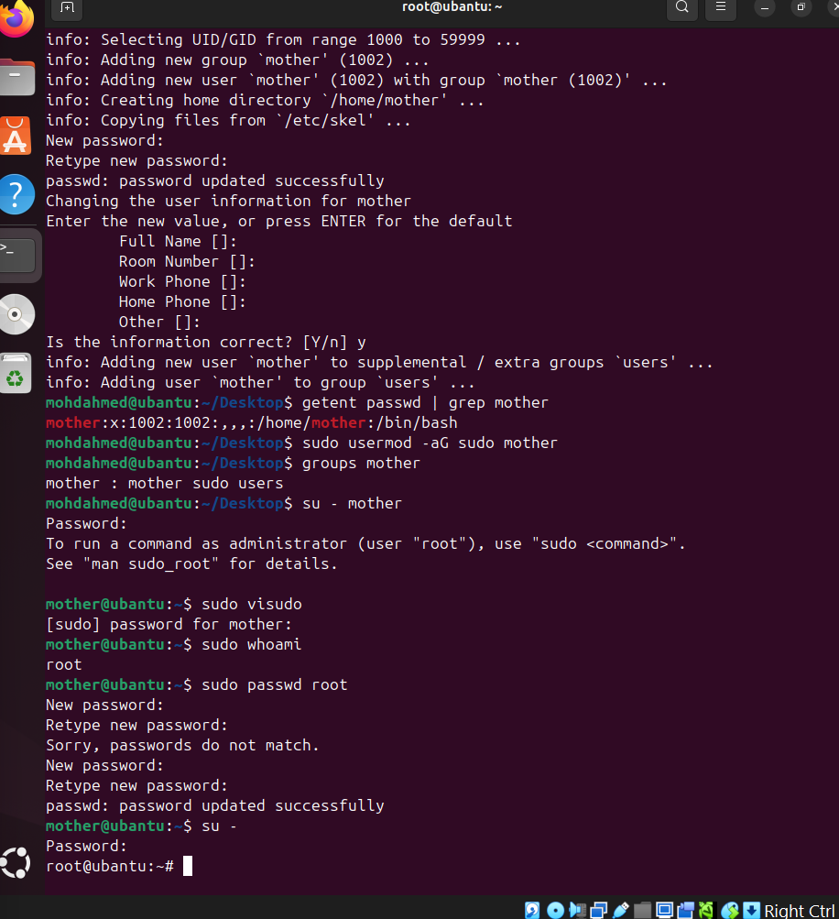

2 Navigate to the home directory. ?

For Navigate to the home directory we will use
Cd command
Cd $home
Cd /home/username

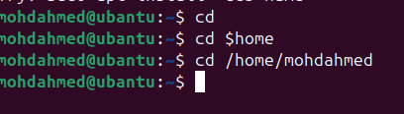
3 Create a new directory.?

To create a new directory The command is
Mkdir Directory Name
For example mkdir techie horizon

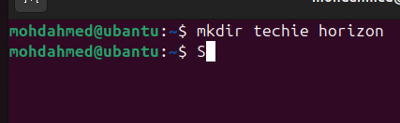

4 List the contents of a directory ?

For list out the all directory we use command
That is : ls

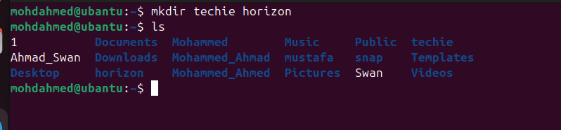

5 Change the current directory.?

For Changing for current directory we use the command for that is
Cd directory name
For example cd Mustafa
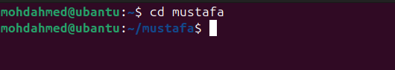

6 Create a new empty file.?

For Creating of new empty file the command we use
That is touch command and file name
For example touch Mashaallah


7 View the contents of a file.?

For View the content of a file We use the command
The command is Cat file Name
Example: cat learner
After hit enter You can see the all content of a file

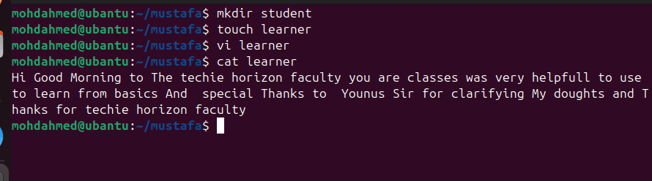

8 Copy a file to another location?
To copy a file to another location the command we use
That is cp file name and destination
For example cp learner desktop
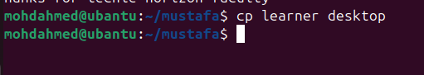
9 Move a file to another location.?
We want to move a file to another location
The command will be mv file and destination
Example : mv learner home
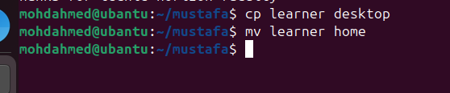

10 Rename a file.?

To Rename a file We use the command
That is
mv old name and new Name
example : mv boss joker

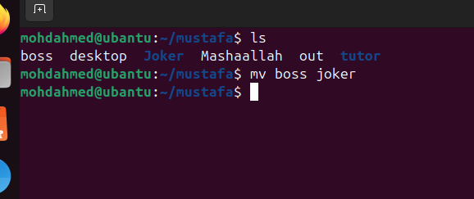

11 Delete a file.?
To delete a file we use command
Rm -rf folder
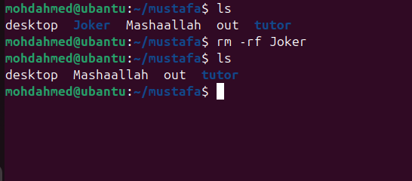

12 Grant or revoke permissions on a file or directory. ?
For Grant permission on file We command is use
That is chmod 777 for all permissions
Example : chmod777 Student

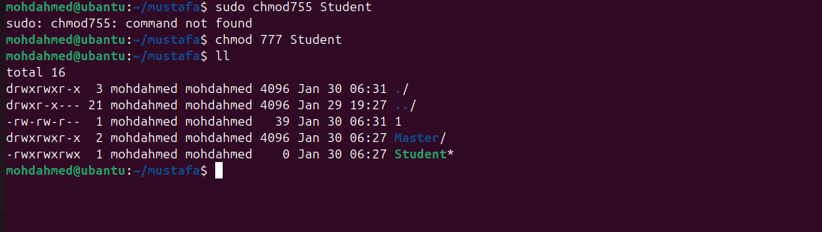
For Revoke or unremoved permissons for a folder We use command
That is chmod 000 file name
Example : chmod 000 Student
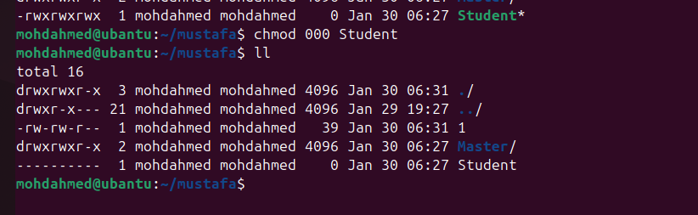

13 View the current date and time ?

For Viewing of current date and time that command we use
That is date



14 Check the system uptime?
To check the uptime in system the command we use
That is uptime 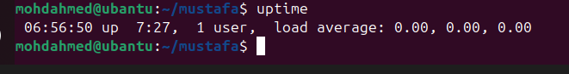

15 View the running processes?
To view the running processes we command we use
That is ef -e
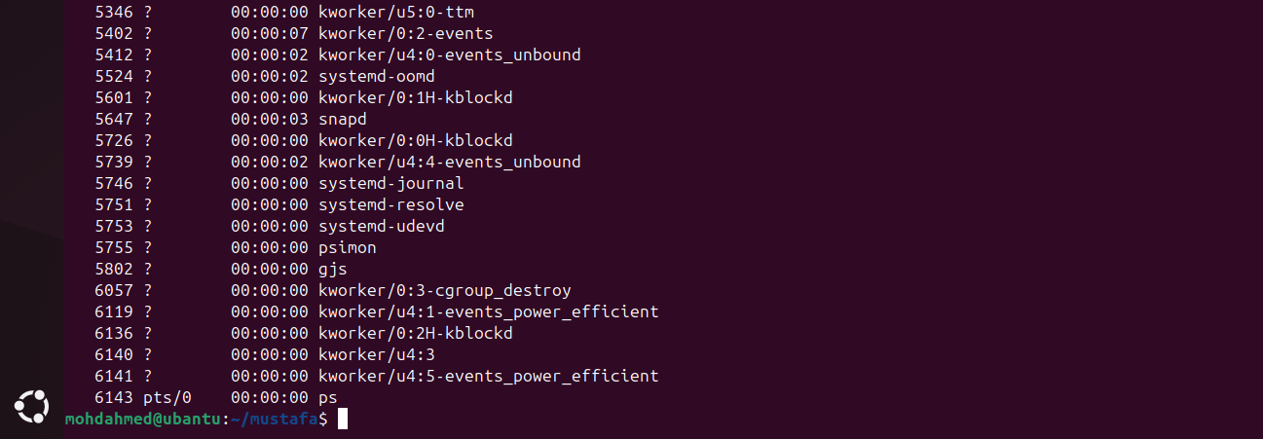
16 Kill a running process.?
If We what to kill the process
Command is kill -9 PiD
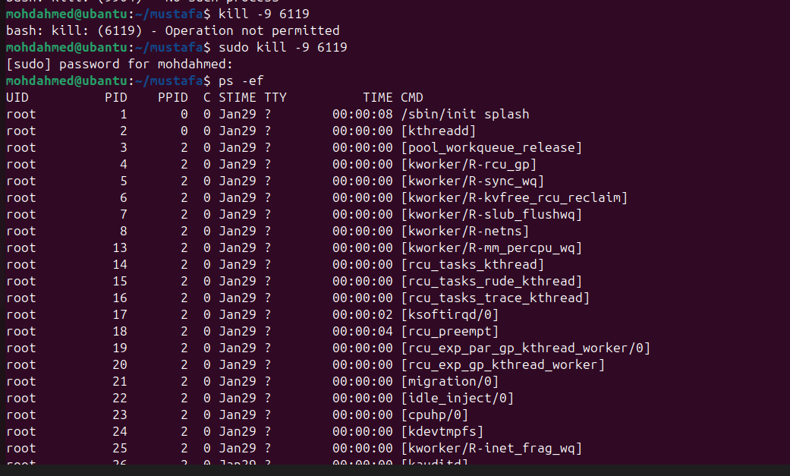

17 Install a package using the package manager (e.g., apt or yum)?
For Install a package like nginx
Frist you need to update the system
The command is sudo apt update
After completion of update
To Install the nginx
The command is sudo apt install nginx

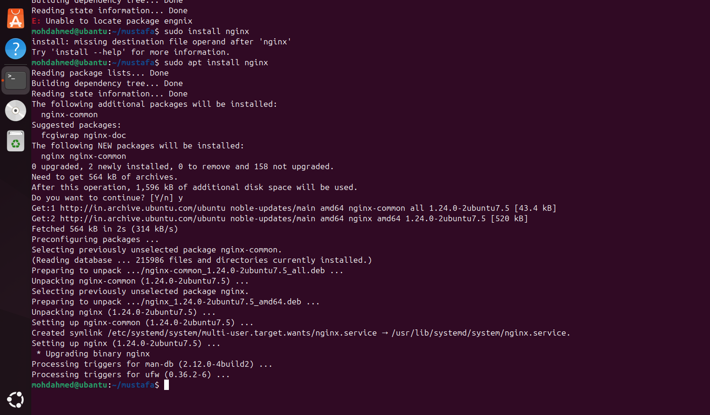

18 Update the system packages?
For update the system packages we use command
That is sudo apt update
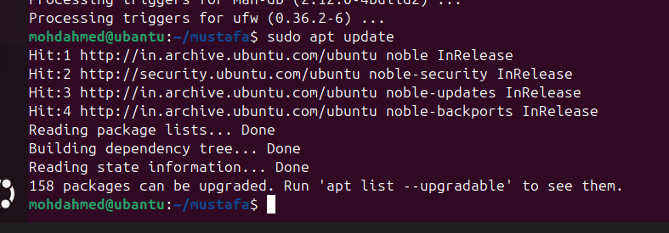

19 Create a symbolic link.?

To create a symbolic link the command is use
That ln -s folder name folder name link
Example ln -s Student Studentlink

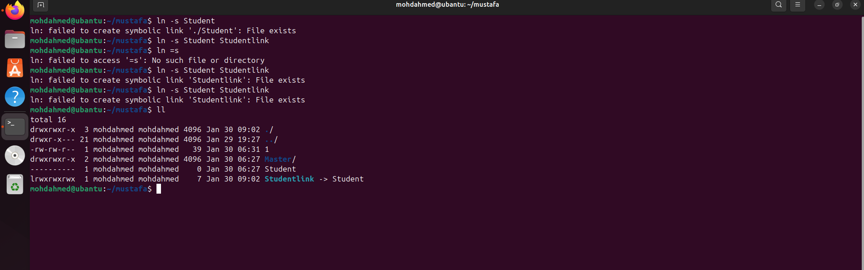

20 Search for files using the find command?
Search a files with help of find command

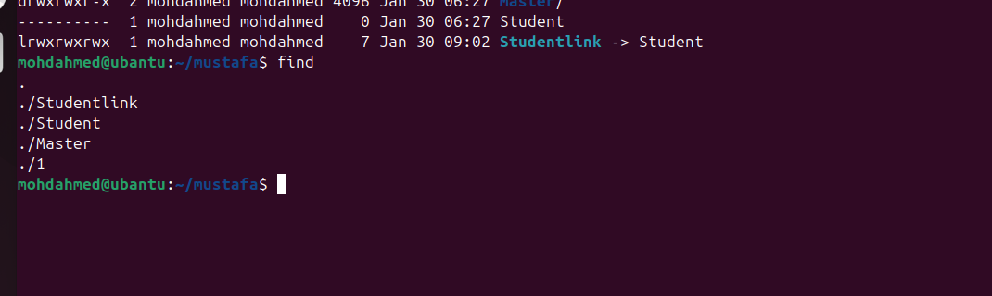

21 Compress and decompress files using tar.?

For compress a files The command we use
That is tar cvf filename.tar filename
Example : tar cvf file1.tar file1

For Decompress a file the Command we use that is
Tar xvf filename.tar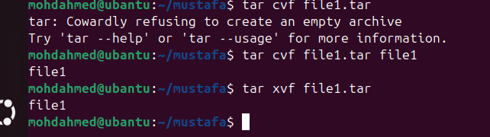
Example : tar xvf file1.tar

22 Monitor system resources with top or htop?
To Monitor System cpu or resources the command we use
That is top command
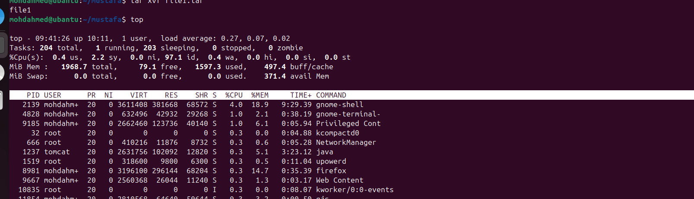

23 Create and manage user groups
Iam create a group we use the command
Sudo groupadd group Name
Examp: sudo groupadd Mohammed
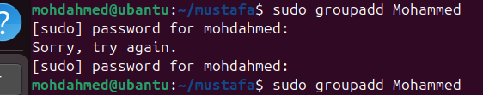
To manage user groups I use command sudo usermod -aG Group Name user name
Example : sudo usermod -aG Mohammed mohdahmed

24 Set up SSH password less authentication?
To set up ssh and password less authentication
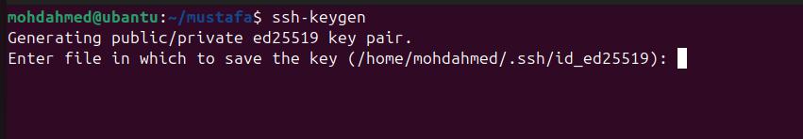
25 Monitor log files using tail or grep.?
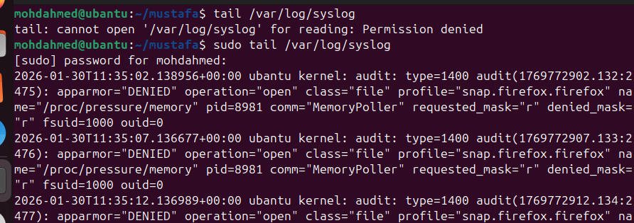
26 Set up a web server (e.g., Apache or Nginx)?

Set up of a apache
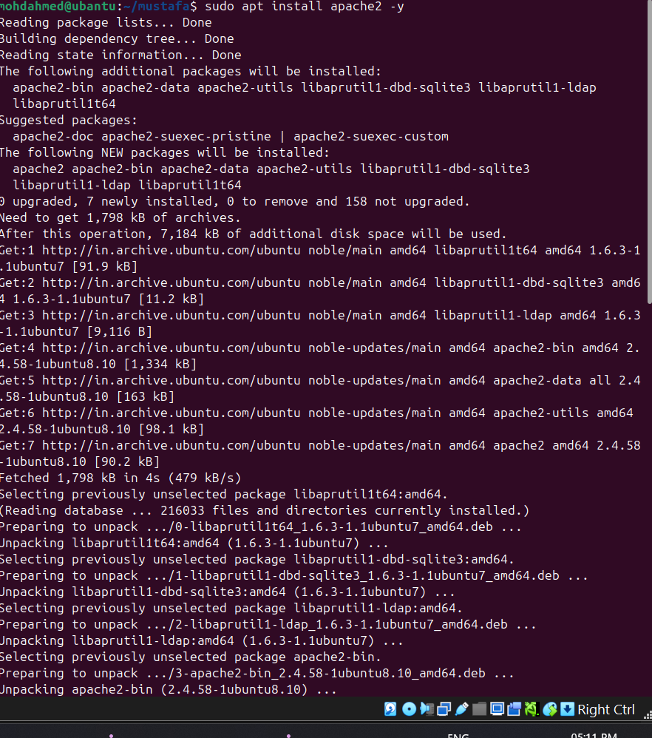

Installation of nginix
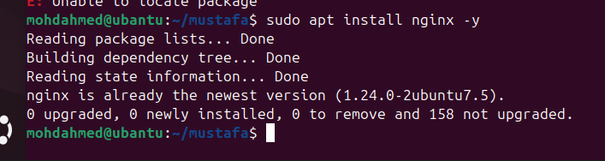
27 Configure and secure a MySQL Database.?
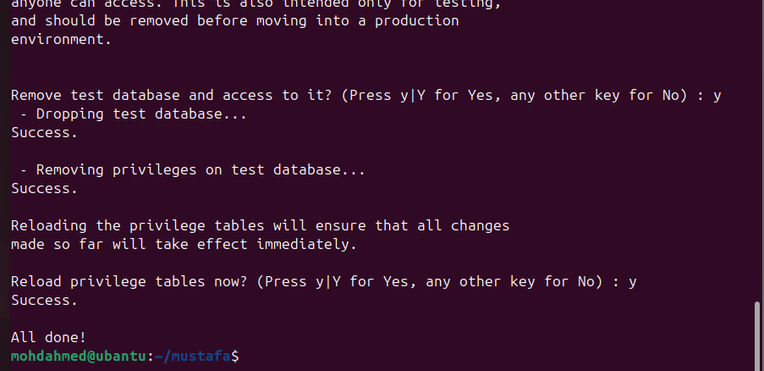

28 set up a Application Server (e.g.,Apache Tomcat)?
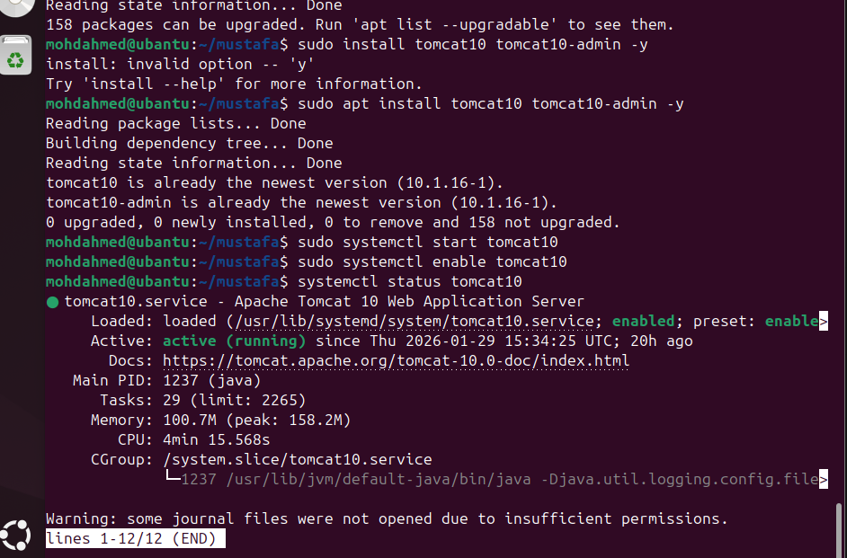

29 create a service file for Apache Tomcat.(Should execute by using systemtctl command)?
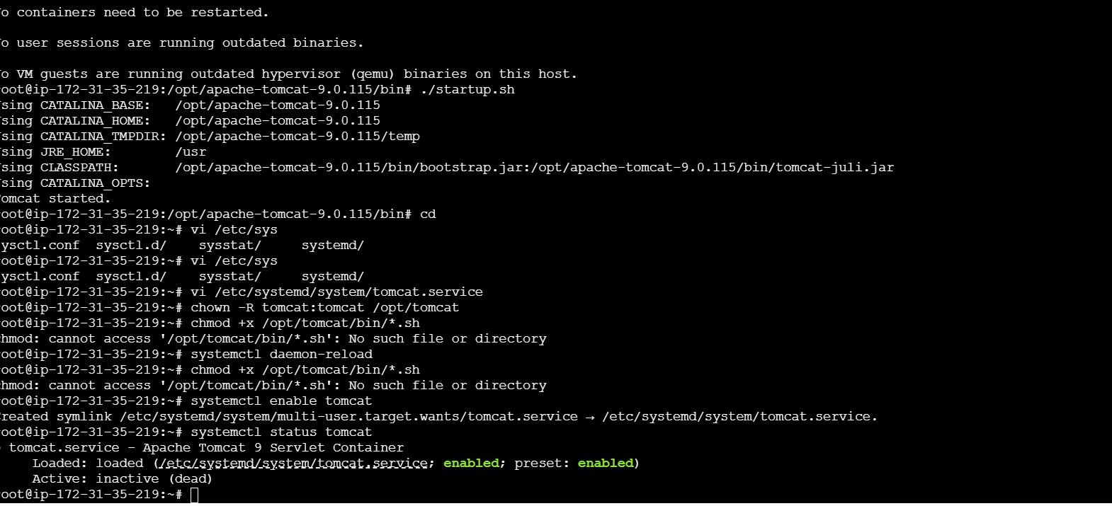

30 Print specific columns from a delimited file.?
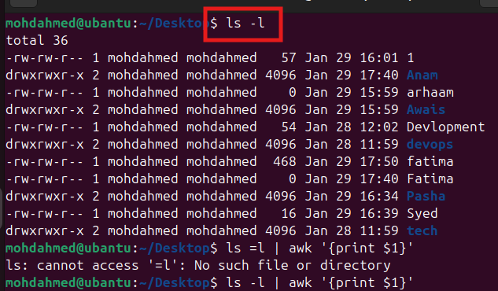
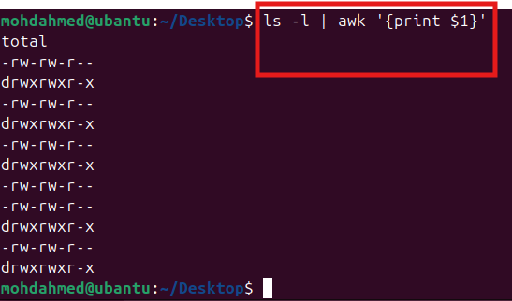

31 Filter and print lines based on a specific pattern or condition.?\
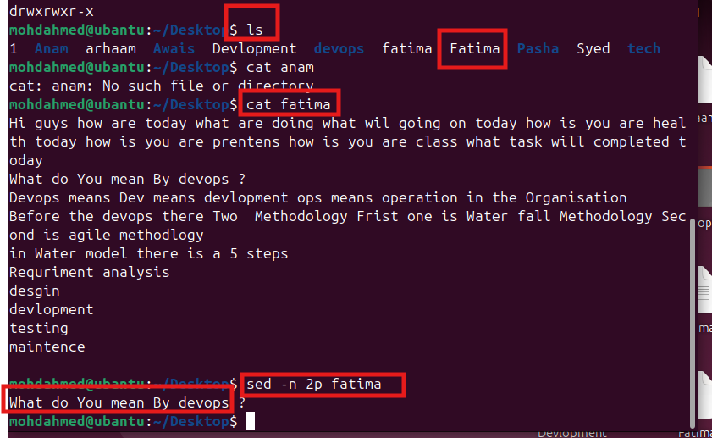

32 Calculate and print the average, sum, or other statistics of a column.?
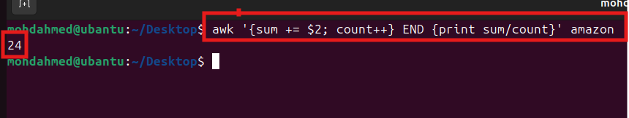
33 Perform string manipulation, such as extracting substrings or changing case?
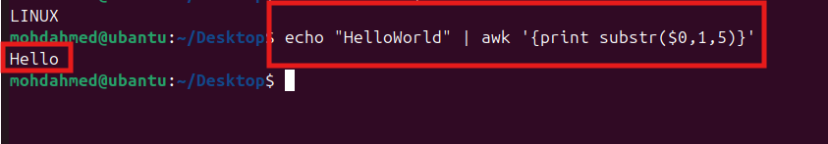
34 Count the occurrences of a specific pattern in a file?
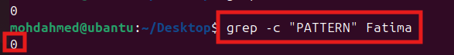

35 Sort lines based on a specific field or column.?
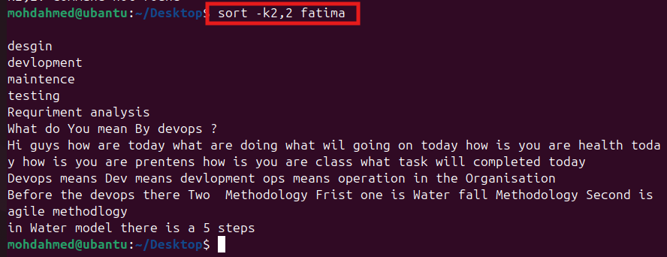

36 Merge multiple files based on a common field or column?
Cammond
We need create 2 files with content, These two files content should be join
In the other file
1 fatima – hello
2 amazon – hi
3 cat fatima amazon > Fatima

Final output : cat Fatima
Hello
Hi
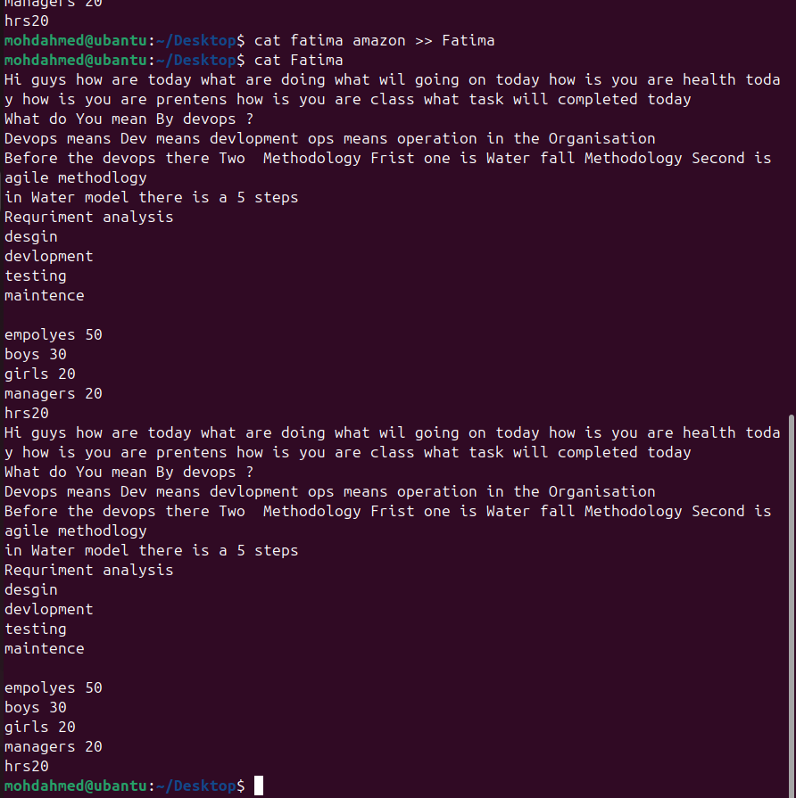

37 Substitute text in a file using search and replace.
For replace a text in a file
Command: sed -I ‘s/old text /new text/g’ filename

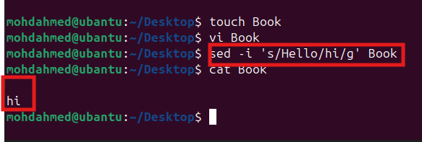
38 Delete specific lines based on a pattern or line number.

If You want delete line from a file
You can use command : sed -I 5d file name
If you want to delete all lines sed -i d file Name
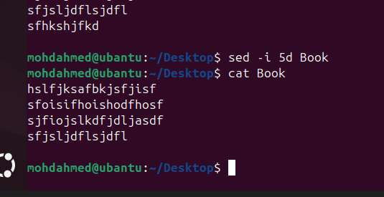

39 Append or insert text before or after a specific pattern or line.

To insert the text in file
Command : sed -I ‘5i\Inserted text and’ filename
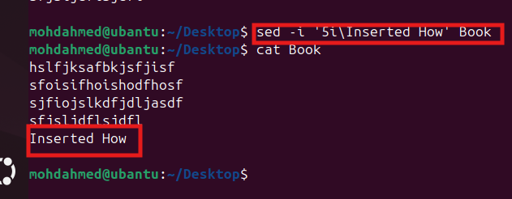

40 Print only specific lines from a file.?

To print line from a file
Command: sed -n ‘5p’ File Name
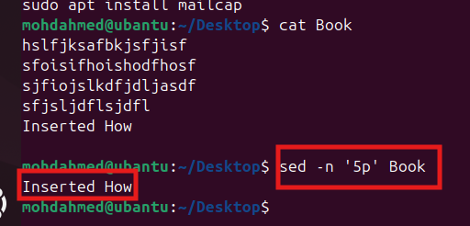

41 Copy file from linux to windows machine ?
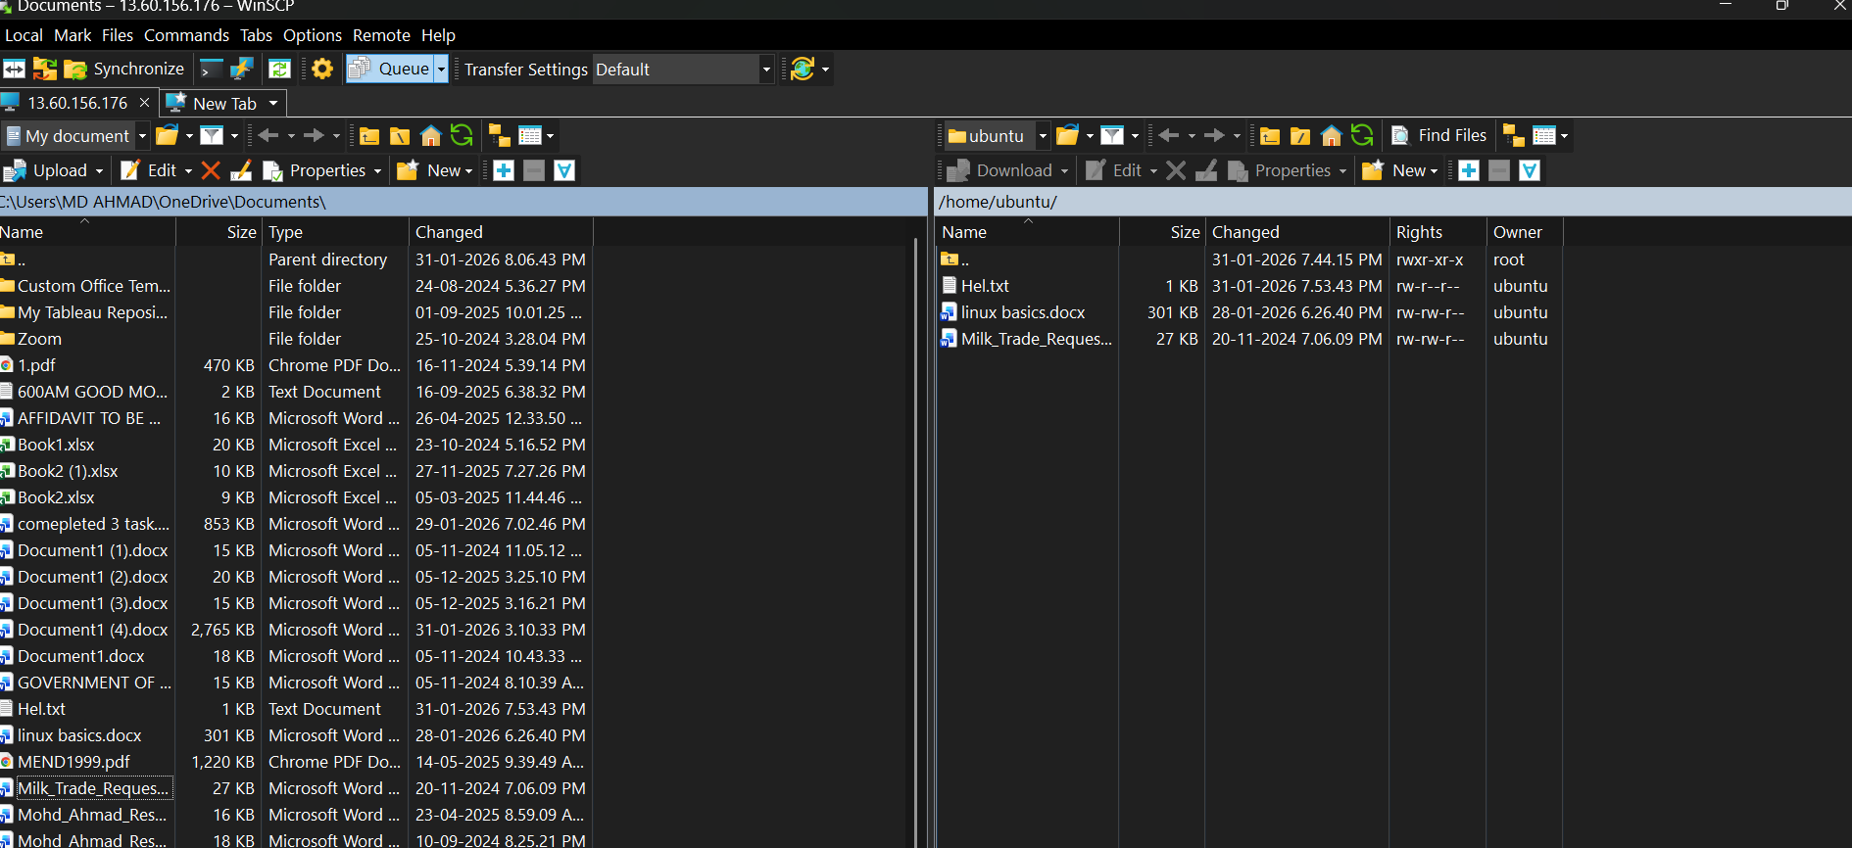

42 5 use cases for AWK and 5 use cases for sed ?
5 use cases of AWK
Column extraction
Log analysis
Data aggregation
Filtering records
Report generation
5 use cases of SED
Search & replace
Delete lines
Insert text
Modify configs
Batch file edits

